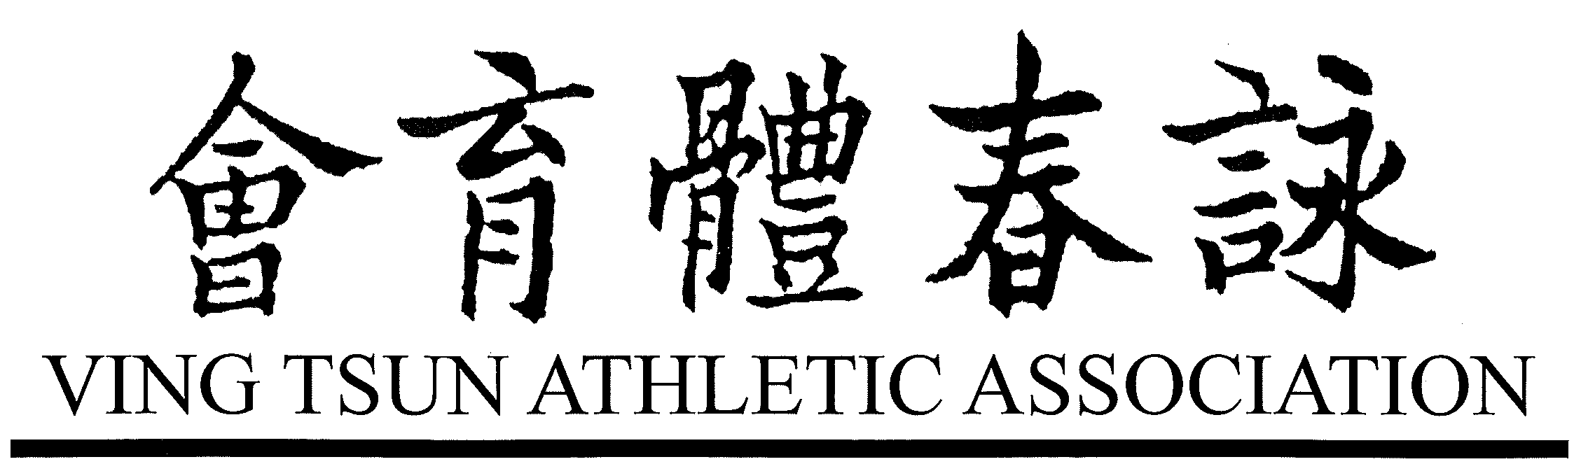
申 請 表 |  |  |  |  | APPLICATION FORM  FOR THE MEMBERSHIP
姓名  NAME : |  |  |  |  |  |  | 性別  SEX : |  | 年齡  AGE :
出生日期  DATE OF BIRTH : |  |  | 籍貫  NATIONALITY : |  |  | 身份證或護照號碼  I.D. CARD / PASSPORT NO. :
申請為  APPLIED FOR : | 永遠會員 PERMANENT ORDINARY MEMBER  永遠會董 PERMANENT DIRECTOR  榮譽會董 PERMANENT HONORARY DIRECTOR
職業  OCCUPATION : |  |  | 辦公處名稱  NAME OF OFFICE :
工作地點  BUSINESS ADDRESS : |  |  |  |  |  |  | 辦公電話  BUSINESS TEL. :
住址  RES. ADDRESS : |  |  |  |  |  |  | 住宅電話  RES. TEL. :
師承  RECEIVED TRAINING FROM : |  |  |  | 介紹人  INTRODUCED BY : |  |  | 申請日期  DATE OF APPLICATION :
照片  PHOTO |  | 申請人簽名  ____________________________  (Signature of the Applicant)
由會方填寫
FOR OFFICE USE ONLY
經手人簽名
ISSUING OFFICER _______________________

